**Functional Requirements**

Software pre-requisites

* Use the Windows/Mac applications
* Use a browser : Microsoft Edge or Google Chrome
* Using a mobile phone : download the Microsoft Teams app (iOS/Android)

User experience

* The Teams meeting doesn’t require a Microsoft Teams account : participants can connect as guest
* In their invitation, the participants will receive a link to connect to Teams :
  + If the link is opened with a mobile device, they will be invited to download the iOS or Android mobile apps
  + If the link is opened from a desktop, they will be redirected to their default internet browser
    - Note : prefer using Microsoft Edge or Google Chrome for best audio/video/sharing experience.
    - If your default browser is not Microsoft Edge or Google Chrome, please copy/paste the meeting Url in one of these browsers



When you download the application you will have two options to access, please choose “sign in”:

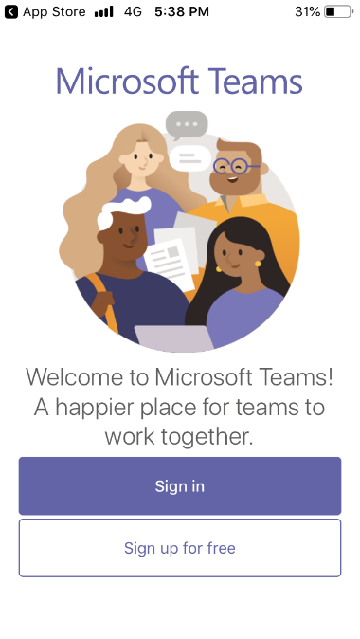

Put your email and allow the app to have microphone access. Finally you are in the meeting.

In the PC if the Teams Application is already installed, the browser may ask if you want to open using the Application : click on Open Teams and follow the steps mentioned before.

                           Or, you can click “Cancel” and then on “Join on the web instead”

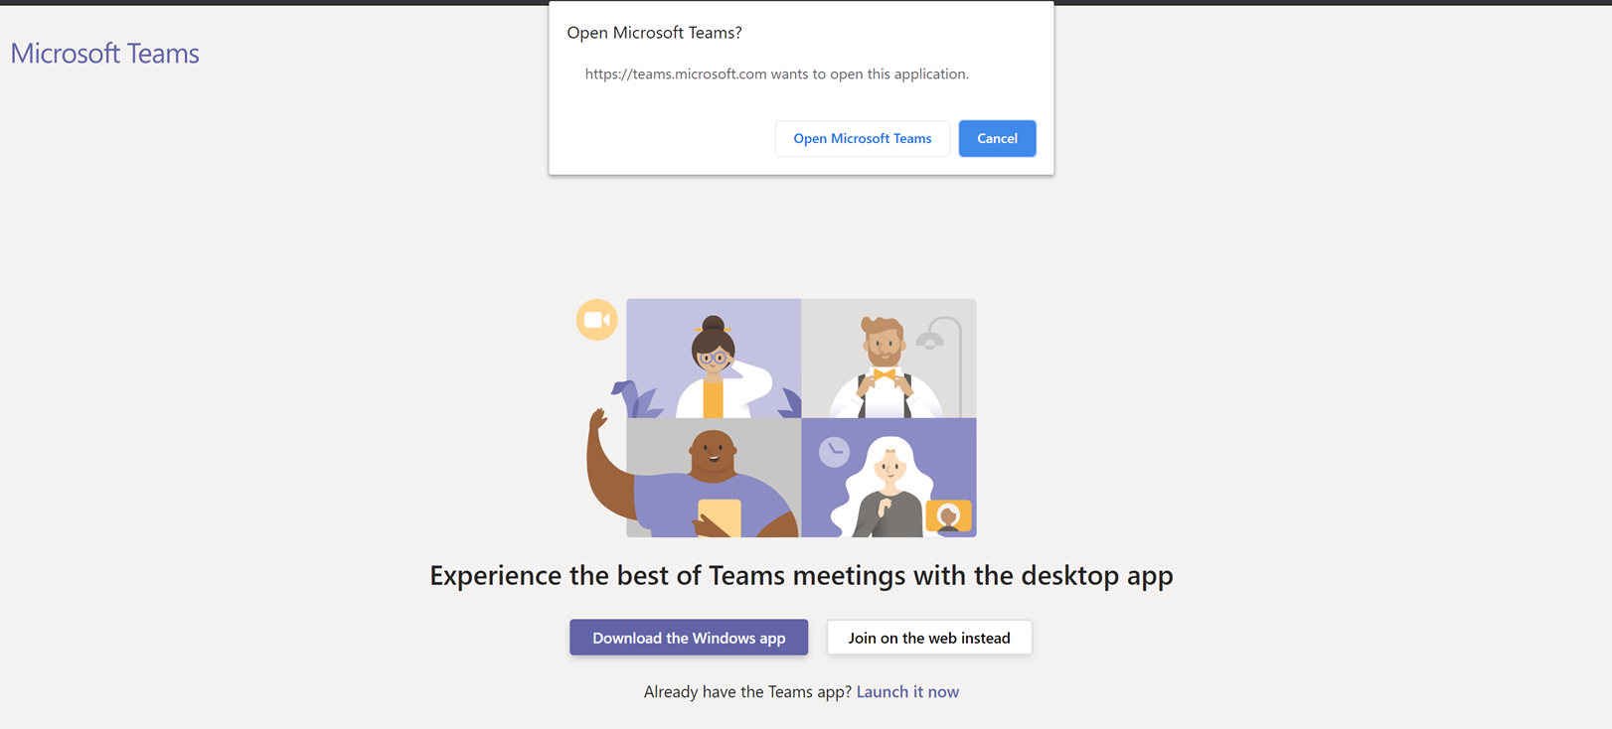

                           Then, the browser will ask for permissions to access the camera and the microphone: click on “Allow” :

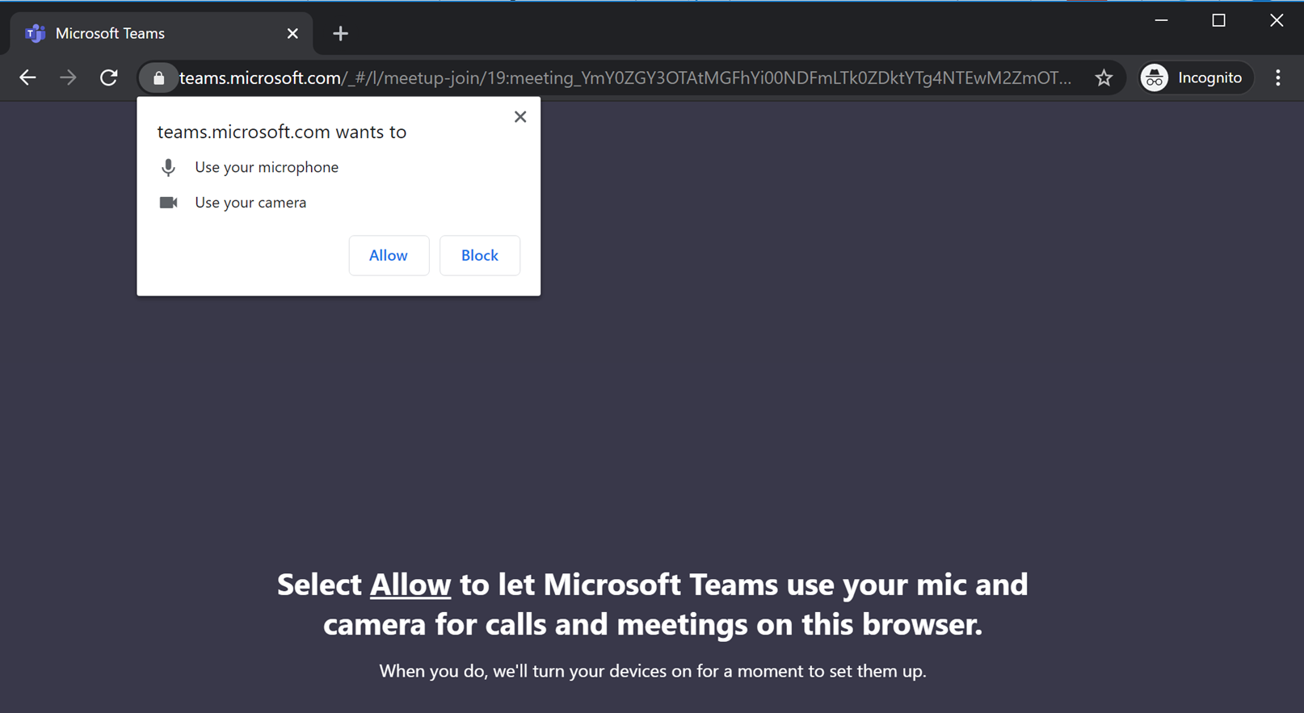

You can then set the audio and video settings prior joining the organizer, and enter your display name :

* + - You can disable your camera if you want
    - You should disable your microphone by yourself prior joining the meeting (you will be able to enable/disable it during the meeting)
    - Enter your name : PLEASE ADD YOUR NAME AND THE NAME OF YOUR COUNTRY
    - If you use an external microphone, speaker or camera, you can review the selected devices using the “Devices” button
    - And Click on Join Now to join the meeting

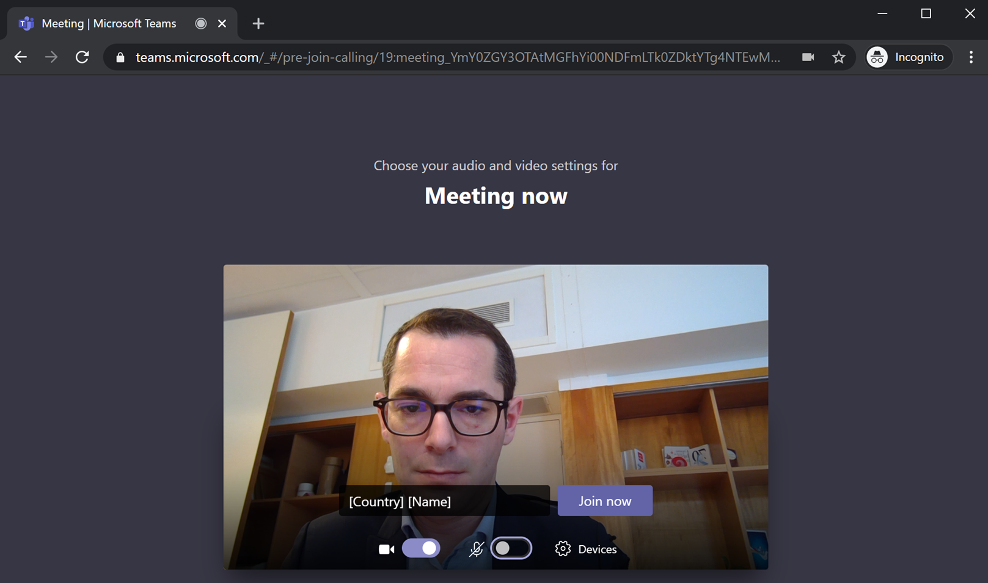

Note : a lobby is configured, you must be accepted by the meeting organizer to join the meeting.